 | Cane River National Heritage Area  Grant Application | 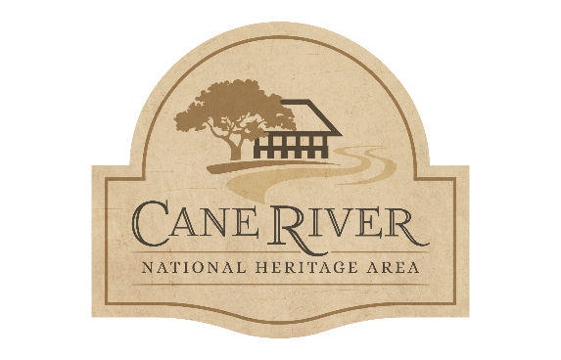
Date |  | Project Title/ Proposal Name
Project Contact |  |  |  |  |  |  |  | Organization Name
Primary Contact Information
Home Phone |  |  |  | Cell Phone |  |  |  |  |  | Email Address
Address
City |  |  |  |  | State. |  |  |  |  |  | ZIP Code
Funding
Applicant Type (Governmental, Non-Profit, Educational Institution, Commercial, Community Org., Tribal Org., Cultural Heritage Org., Individual)

Funding Category (Historic Preservation and Enhancement, Conservation & Collections, Land & Water Conservation, Recreation, Education & Public Learning, Promotion & Marketing)

Funding Amount Requested |  |  |  |  |  |  | Project Time Frame

Project Proposal

Please provide a brief, 300 words or less, summary of the proposed project.

Please answer the following questions in 3-5 sentences.
How will your project benefit the public? Do you expect any social, community, or quality of life impacts as a result of your project?

Will your project have a regional or multi-parish impact? If so, please explain.

How do you plan to publicize your project/ event and acknowledge the support of Cane River National Heritage Area, Inc. partnership?

What previous experience do you or your organization have with managing or completing projects of this nature?

Budget Summary

Please complete the following budget chart and match summary for your project. Please ensure that all the columns are totaled correctly and that your match equals or exceeds your request.
Categories | Request | Cash Match | In-Kind Match | Subtotals
Consultant
Contract for Services
Equipment
Materials & Supplies
Personnel
Travel
Marketing
Other
Totals

A 50/50 match is required for all funded projects, this includes the Cash and In-Kind funds.
Grant funds are allocated on a reimbursable basis upon receipt of final invoicing
and a complete Final Report.

Budget Narrative: Please write a short explanation for the expense funded by the grant.

In-Kind Sources: Please list your sources for the In-Kind Match column.
(volunteer personnel, non-monetary donations, etc.)

Cash Sources: Please list the sources of your Cash Match column.
(funds provided by the organization/ individual, monetary donations towards the project, etc.)

Please list any additional partnerships that are associated with this project.

I certify the information contained within this application to be accurate and I fully understand the requirements and obligations of the Cane River National Heritage Area, Inc. grant program.
Signature of Authorizing Official

CRNHA Office Use Only
Receipt Date | Personnel

